Training Models

# Linear Regression

Equation of Line , y = mx+c

C = Intercept/Bias, where it intercepts the y-axis. If c=0, it will pass through origin(0,0). It is constant & doesn’t depends on any of the features.

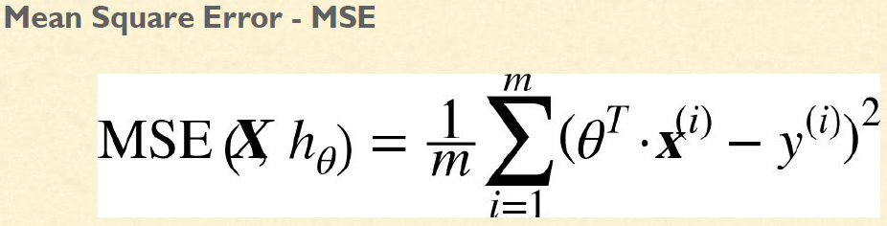

**There are two approaches to train the linear regression model**

* The normal “closed-form” equation
* Gradient Descent (GD) - Iterative optimization approach

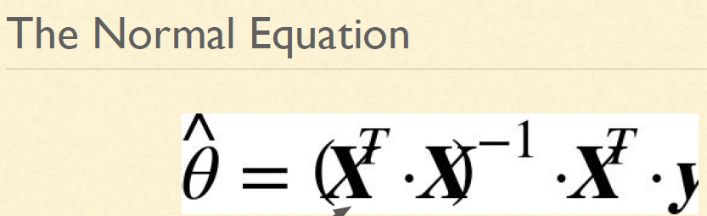

import numpy as np

**#Uniformly Distributed Array**

X= 2 * np.random.rand(100,1)

y= 4 + 3 * X + np.random.rand(100,1)

plt.plot(X, y, "b.")

plt.xlabel("$x_1$", fontsize=18)

plt.ylabel("$y$", rotation=0, fontsize=18)

plt.axis([0, 2, 0, 15])

plt.show()

**#Add Bias to Dataset**

X_b = np.c_[np.ones((100,1)),X]

**#Apply the Normal Equation to compute theta hat**

theta_best = np.linalg.inv(X_b.T.dot(X_b)).dot(X_b.T).dot(y)

**#Make Prediction using theta_best**

X_new = np.array([[0],[2]])

X_new_b = np.c_[np.ones((2,1)),X_new]

Y_predict = X_new_b.dot(theta_best)

**#Plot the Predictions**

plt.plot(X_new, y_predict, "r-", linewidth=2, label="Predictions")

plt.plot(X, y, "b.")

plt.xlabel("$x_1$", fontsize=18)

plt.ylabel("$y$", rotation=0, fontsize=18)

plt.legend(loc="upper left", fontsize=14)

plt.axis([0, 2, 0, 15])

plt.show()

**#Using Scikit-Learn**

from sklearn.linear_model import LinearRegression

lin_reg = LinearRegression()

lin_reg.fit(X,y)

lin_reg.intercept_,lin_reg.coef_

lin_reg.predict(X_new)

🡪Computational Complexity = O(n3), where n = no. of features. So if features got increased it will be very slow.

# Gradient Descent

Measures the local gradient of the cost function with regards to the parameter vector θ and it goes in the direction of descending gradient until the gradient becomes zero.

* Start by filling θ with random values - Random initialization
* Each step is also called as **Learning Rate.**  If Learning Rate is too small, then it will take long time to converge. If the Learning Rate is too large, it will keep on bouncing.
* **Problem :** Local Minima,holes,ridges,plateaus
* **FeatureScaling** must need to be implemented while using Gradient Descent.
* **Gradient Descent Algorithms : Batch GD, Stochastic GD & Mini-Batch GD.**
* *Batch Gradient Descent :*
  + Random Initialization : Initialize model Parameter.
  + ***Partial Derivative*** : For each of the weights, we change one weight and keeping others fixed and calculate the change in cost
  + ***Partial Derivative Cost Function*** :

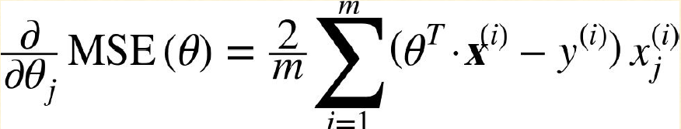

***This formula involves calculations over the full training set X at every step, therefore the name Batch Gradient Descent***

* + *It is better than Linear Regression when no. of features is more. But is very slow on large Datasets since it uses entire Dataset for each step.*

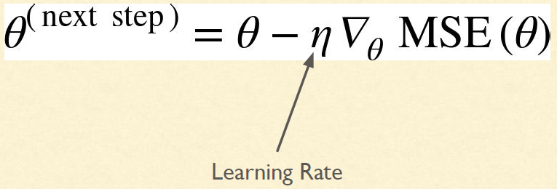

**#Batch Gradient Descent**

eta = 0.01 #Learning Rate

n_iterations = 100

m = 100

theta = np.random.randn(2,1) #Radom initialization of weight

for iteration in range(n_iterations):

gradients = 2/m * X_b.T.dot(X_b.dot(theta)-y)

theta = theta-eta*gradients

if iteration % 50 :

print (theta)

**# Plot Gradient Descent for various learning rates**

theta_path_bgd = []

def plot_gradient_descent(theta, eta, theta_path=None):

m = len(X_b)

plt.plot(X, y, "b.")

n_iterations = 1000

for iteration in range(n_iterations):

if iteration < 10:

y_predict = X_new_b.dot(theta)

style = "b-" if iteration > 0 else "r--"

plt.plot(X_new, y_predict, style)

gradients = 2/m * X_b.T.dot(X_b.dot(theta) - y)

theta = theta - eta * gradients

if theta_path is not None:

theta_path.append(theta)

plt.xlabel("$x_1$", fontsize=18)

plt.axis([0, 2, 0, 15])

plt.title(r"$\eta = {}$".format(eta), fontsize=16)

np.random.seed(42)

theta = np.random.randn(2,1) # random initialization

plt.figure(figsize=(10,4))

plt.subplot(131); plot_gradient_descent(theta, eta=0.02)

plt.ylabel("$y$", rotation=0, fontsize=18)

plt.subplot(132); plot_gradient_descent(theta, eta=0.1, theta_path=theta_path_bgd)

plt.subplot(133); plot_gradient_descent(theta, eta=0.5)

save_fig("gradient_descent_plot")

plt.show()

***Find Good Learning Rate - Solution***

*Set a very large number of iterations and Interrupt the algorithm when the gradient vector becomes tiny When norm of a gradient vector becomes smaller than ϵ - tolerance*

# Stochastic Gradient Descent

**Problem with Batch Gradient Descent**

* Slow when the training set is large, as it uses the whole training set to compute the gradient at every step

**Stochastic Gradient Descent**

* Just picks a random instance in the training set at every step and Computes the gradients based only on that single instance
* Once the Algorithm stops, final parameters values are good but not optimal.
* **Simulated Annealing** is the solution process by which **Learning Rate** gradually decreases.
* **Learning Schedule** is a function which determines the change in **Learning Rate** at each iteration.
* Each Round or iteration is called **EPOCH.**

m = len(X_b)

np.random.seed(42)

n_epochs = 50

t0,t1 = 5,50 #Learning Schedule Hyperparameter

def learning_schedule(t):

return t0/(t+t1)

theta = np.random.randn(2,1) #Random initialization

theta_path_sgd = []

for epoch in range (n_epochs):

for i in range(m):

if epoch ==0 and i<20:

y_predict = X_new_b.dot(theta)

style = “b-” if i > 0 else “r--”

plt.plot(X_new,y_predict,style)

random_index = np.random.randint(m)

xi = X_b[random_index:random_index+1]

yi = y[random_index:random_index+1]

gradients = 2*xi.T.dot(xi.dot(theta)-yi)

eta = learning_schedule(epoch*m+i)

theta = theta – eta * gradients

theta_path_sgd.append(theta)

plt.plot(X,y,”b.”)

plt.xlabel("$x_1$", fontsize=18)

plt.ylabel("$y$", rotation=0, fontsize=18)

plt.axis([0, 2, 0, 15])

save_fig("sgd_plot")

plt.show()

**#Linear regression using Scikit SGD Regressor**

from sklearn.linear_model import SGDRegressor

sgd_reg = SGDRegressor(n_iter=50,penalty=None,eta0=0.1,random_state=42)

sgd_reg.fit(X,y.ravel())

sgd_reg.intercept_,sgd_reg.coef_

# Mini-Batch Gradient Descent

Computes gradient on small random sets of instances

theta_path_mgd = []

n_iterations = 50

minibatch_size = 20

np.random.seed(42)

theta = np.random.randn(2,1)

t0,t1 = 10,1000

def learning_schedule(t):

return t0/(t+t1)

t= 0

for epoch in range(n_iterations):

shuffled_indices = np.random.permutations(m)

X_b_shuffled = X_b[shuffled_indices]

y_shuffled = y[shuffled_indices]

xi = X_b_shuffled[:minibatch_size]

yi = y_shuffled[:minibatch_size]

gradients = 2 * xi.T.dot(xi.dot(theta)-yi)

eta = learning_schedule(epoch)

theta = theta-eta*gradients

theta_path_mgd.append(theta)

***# Plot paths taken by the 3 Gradient Descent algorithms during training***

theta_path_bgd = np.array(theta_path_bgd)

theta_path_sgd = np.array(theta_path_sgd)

theta_path_mgd = np.array(theta_path_mgd)

plt.figure(figsize=(7,4))

plt.plot(theta_path_sgd[:, 0], theta_path_sgd[:, 1], "r-s", linewidth=1, label="Stochastic")

plt.plot(theta_path_mgd[:, 0], theta_path_mgd[:, 1], "g-+", linewidth=2, label="Mini-batch")

plt.plot(theta_path_bgd[:, 0], theta_path_bgd[:, 1], "b-o", linewidth=3, label="Batch")

plt.legend(loc="upper left", fontsize=16)

plt.xlabel(r"$\theta_0$", fontsize=20)

plt.ylabel(r"$\theta_1$ ", fontsize=20, rotation=0)

plt.axis([2.5, 4.5, 2.3, 3.9])

save_fig("gradient_descent_paths_plot")

plt.show()

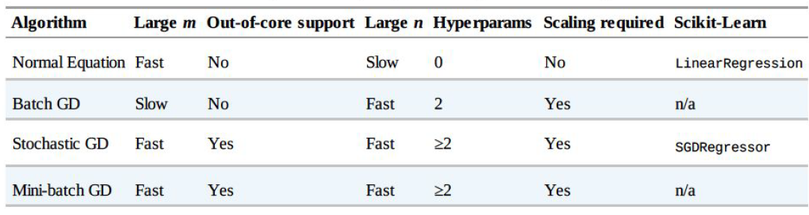

# Polynomial Regression

A linear Model to fit non-linear data.

Feature = n, Degree = d. Transform array = n+d!/n!d!

***# Generate nonlinear and noisy dataset***

import numpy as np

import numpy.random as rnd

np.random.seed(42)

m=100

X = 6 * np.random.rand(m,1)-3

y = 0.5 * X**2 + X + 2 + np.random.randn(m,1)

plt.plot(X,y,’b.’)

plt.xlabel(“$X_1$”,fontsize=18)

plt.ylabel(“$y$”,fontsize=18)

plt.axis([-3,3,0,10])

***# Add new features using Scikit's Learn PolynomialFeatures class***

from sklearn.preprocessing import PolynomialFeatures

poly_features = PolynomialFeatures(degree=3,include_bias=False)

X_poly = poly_features.fit_transform(X)

***# Fit LinearRegression model***

from sklearn.linear_model import LinearRegression

lin_reg = LinearRegression()

lin_reg.fit(X_poly,y)

lin_reg.intercept_,lin_reg.coef_

***# Polynomial Regression model predictions***

X_new=np.linspace(-3, 3, 100).reshape(100, 1)

X_new_poly = poly_features.transform(X_new)

y_new = lin_reg.predict(X_new_poly)

plt.plot(X, y, "b.")

plt.plot(X_new, y_new, "r-", linewidth=2, label="Predictions")

plt.xlabel("$x_1$", fontsize=18)

plt.ylabel("$y$", rotation=0, fontsize=18)

plt.legend(loc="upper left", fontsize=14)

plt.axis([-3, 3, 0, 10])

plt.show()

* **Learning Curve**

***# High degree polynomials***

**from** **sklearn.preprocessing** **import** StandardScaler

**from** **sklearn.pipeline** **import** Pipeline

**for** style, width, degree **in** (("g-", 1, 300), ("b--", 2, 2), ("r-+", 2, 1)):

polybig_features = PolynomialFeatures(degree=degree,include_bias=**False**)

std_scaler = StandardScaler()

lin_reg = LinearRegression()

polynomial_regression = Pipeline([

("poly_features", polybig_features),

("std_scaler", std_scaler),

("lin_reg", lin_reg),

])

polynomial_regression.fit(X, y)

y_newbig = polynomial_regression.predict(X_new)

plt.plot(X_new, y_newbig, style, label=str(degree), linewidth=width)

plt.plot(X, y, "b.", linewidth=3)

plt.legend(loc="upper left")

plt.xlabel("$x_1$", fontsize=18)

plt.ylabel("$y$", rotation=0, fontsize=18)

plt.axis([-3, 3, 0, 10])

plt.show()

* **If Model is Over-fitting, one of the Solution is ‘Cross-Validation’. Other one is Learning Curve.**

*# Learning curves of the plain Linear Regression model*

**from** **sklearn.metrics** **import** mean_squared_error

**from** **sklearn.model_selection** **import** train_test_split

**def** plot_learning_curves(model, X, y):

X_train, X_val, y_train, y_val = train_test_split(X, y, test_size=0.2, random_state=10)

train_errors, val_errors = [], []

**for** m **in** range(1, len(X_train)):

model.fit(X_train[:m], y_train[:m])

y_train_predict = model.predict(X_train[:m])

y_val_predict = model.predict(X_val)

train_errors.append(mean_squared_error(y_train_predict, y_train[:m]))

val_errors.append(mean_squared_error(y_val_predict, y_val))

plt.plot(np.sqrt(train_errors), "r-+", linewidth=2, label="train")

plt.plot(np.sqrt(val_errors), "b-", linewidth=3, label="val")

plt.legend(loc="upper right", fontsize=14)

plt.xlabel("Training set size", fontsize=14)

plt.ylabel("RMSE", fontsize=14)

lin_reg = LinearRegression()

plot_learning_curves(lin_reg, X, y)

plt.axis([0, 80, 0, 3])

plt.show()

**🡪** If **RMSE** is very high, then it means Model is Underfitting. Then either we need to add more dataset or more features need to be added or more complex model needs to be selected.

***# Learning curves of the 10th-degree polynomial model on the same data***

**from** **sklearn.pipeline** **import** Pipeline

polynomial_regression = Pipeline([

("poly_features", PolynomialFeatures(degree=10, include_bias=**False**)),

("lin_reg", LinearRegression()),

])

plot_learning_curves(polynomial_regression, X, y)

plt.axis([0, 80, 0, 3])

plt.show()

🡪 The Bias / Variance Tradeoff : A model’s generalization error can be expressed as the sum of three very different errors :

* Bias : High Bias leads to UNDERFIT the model.
* Variance : High Variance/More Features leads to OVERFIT the model.
* Irreducible error : Clean the data.

**More complex model means High Variance and Low Bias & vice-versa.**

* **Regularized Linear Models**
* To regularize a Polynomial Model, reduce the number of polynomial degree.
* To regularize a Linear Model, constrain the weights of the model. Three ways to constrain the weight :
  + **Ridge Regression**
  + **Lasso Regression**
  + **Elastic Net**
* **RMSE** is the preferred performance measure for Regression Task. But, in some case, like-when there are many outliers **MAE –(Mean Absolute Error/Average Absolute Deviation)** can be used.

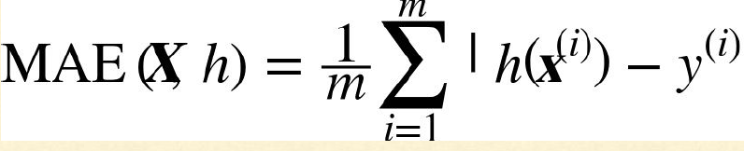

* **There are various distance measures or norm to calculate distance between two vectors**
  + **Manhattan/L1 Norm :** Orthogonal line. Computing the sum of absolutes (MAE) corresponds to L1 Norm. Denoted as //.//1
  + **Euclidean Norm/L2 norm :** Straight Line between two points. Computing the root of a squares(RMSE) corresponds to L2 norm. Denoted as //.//2 or //.//

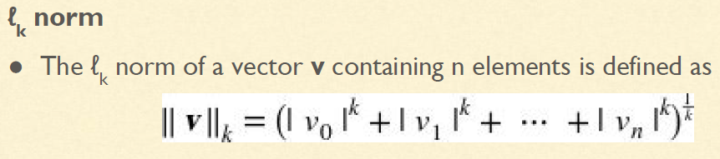

🡪The Higher the Norm index, more it focuses on large values & ignores the small ones.

🡪L1 norm yield sparse matrix, which helps in feature selection. i.e., which feature is important, and which is redundant.

# Ridge Regression

Regularized version of Linear Regression. A regularization term is added to the Cost Function.